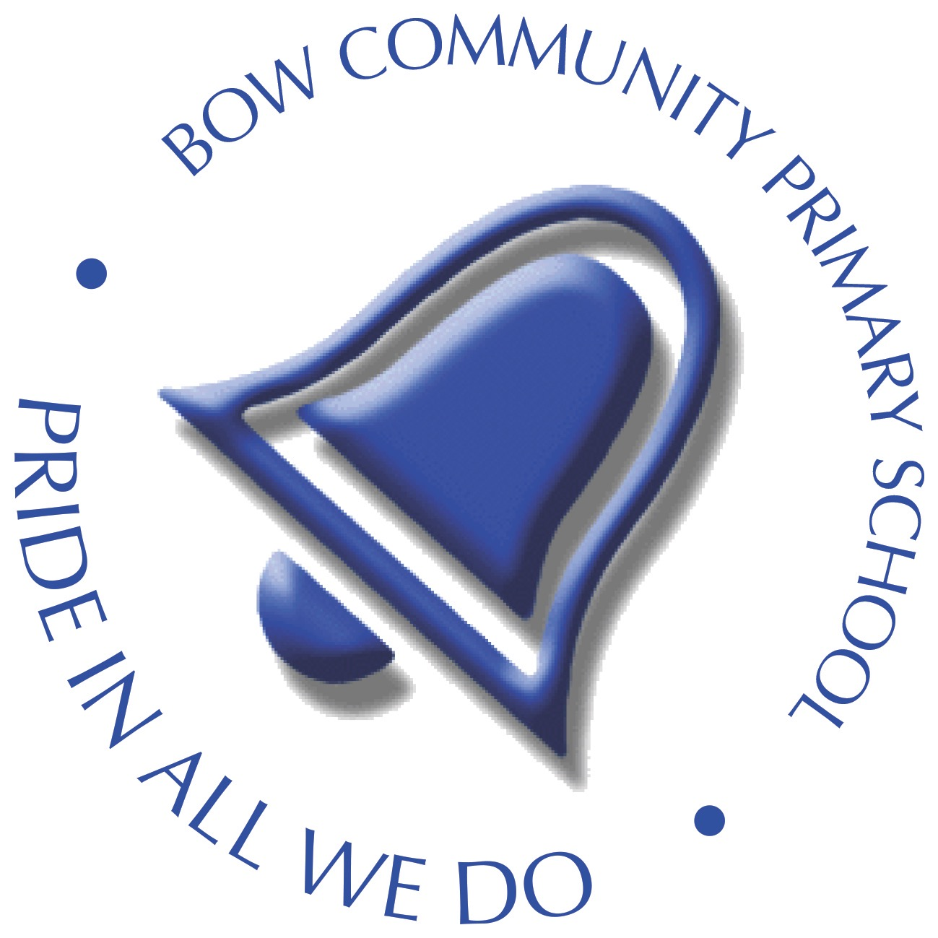
Bow Community Primary School
Anti-Bullying Policy

1. Statement of Intent
At Bow Community Primary School, we are committed to providing a safe, supportive, and inclusive environment where every child feels valued, respected, and secure. We have a zero-tolerance approach to bullying and treat any form of bullying as a serious matter.
All incidents are dealt with promptly, consistently, and in line with our school values: Respect, Ready, and Safe. We take a restorative, supportive, and proactive approach that prioritises the needs of the person who has experienced bullying, while ensuring appropriate consequences and support are in place for the child displaying bullying behaviour.
This policy sets out our responsibilities and procedures for preventing and responding to bullying, in line with current guidance from the Department for Education.

2. Aims and Objectives
- To promote a culture where bullying is not tolerated and where children feel empowered to speak up and seek support.
- To ensure that pupils, staff, and families understand what constitutes bullying and how to report it.
- To provide a consistent response to bullying incidents, including those related to race, religion, gender, disability, special educational needs, or sexual orientation.
- To support pupils’ wellbeing and provide appropriate pastoral and, if necessary, external support following any incidents.
- To work closely with families and outside agencies where appropriate, to resolve incidents and prevent recurrence.

3. What is Bullying?
In line with DfE guidance, bullying is defined as:
“Behaviour by an individual or group, repeated over time, that intentionally hurts another individual or group either physically or emotionally.”
At Bow Community Primary School, we use the pupil-friendly definition:
S.T.O.P. – Several Times On Purpose.
Bullying can take many forms, including:
- Physical – hitting, kicking, pushing, taking belongings
- Verbal – name-calling, threats, teasing
- Emotional – excluding, spreading rumours, manipulation
- Online (Cyberbullying) – using social media, messaging apps or gaming platforms to intimidate, threaten, or target others
- Prejudice-based bullying – including racism, homophobia, biphobia, transphobia, sexism, or targeting children with disabilities
Not all hurtful behaviour is bullying. One-off incidents or occasional unkindness should still be addressed but are not defined as bullying unless they are deliberate, repeated, and targeted.

4. Prevention Strategies
A whole-school approach that embeds our values through the curriculum, assemblies, school council, and pupil voice activities.
The PSHE/RSE curriculum covers respectful relationships, online safety, and the impact of bullying.
Anti-Bullying Week and regular pupil workshops/assemblies to reinforce expectations.
Adults in school model respectful, inclusive behaviour at all times.
Staff monitor behaviour trends using CPOMS and act swiftly when concerns arise.
Supervision in less structured parts of the school day (e.g. playtimes, corridors) is robust.

5. Online Bullying
Teach safe and respectful online behaviour through our computing and PSHE curriculum.
Encourage pupils to report any online concerns to a trusted adult.
Work closely with families to address online bullying and promote safe digital use at home.
Report serious incidents to relevant authorities (e.g. police, child protection services) where appropriate.

6. Responding to Bullying
All incidents of bullying are taken seriously and dealt with as follows:
- The pupil who has experienced bullying will be listened to, supported, and protected.
- A full investigation will be carried out by staff, and outcomes recorded on CPOMS.
- Families of both parties will be informed at the earliest opportunity.
- The school uses a restorative approach, encouraging accountability and understanding, while implementing proportionate consequences.
- Repeated incidents will involve a Behaviour Support Plan and, where appropriate, the involvement of external services.
- Exclusion (fixed-term or permanent) may be considered for severe or persistent bullying.

7. Roles and Responsibilities

Pupils:
- Treat others with respect and follow the school rules: Respectful, Ready, Safe.
- Report any bullying to a trusted adult.
- Take part in pupil voice, School Council discussions, and anti-bullying activities.
Staff:
- Be vigilant and act promptly on any concerns or disclosures.
- Record incidents using CPOMS and inform relevant leaders.
- Support all pupils involved, ensuring needs are met and that learning continues.
- Promote the school values at all times and model positive behaviour.
Headteacher and SLT:
- Monitor bullying data, identify patterns, and take strategic action.
- Ensure staff receive training to identify and manage bullying appropriately.
- Maintain a culture of openness and support where pupils feel safe to speak out.
Governors:
- Ensure the school fulfils its duties under the Equality Act 2010.
- Review bullying incidents and monitor the effectiveness of the policy.
- Hear concerns from families as part of the school’s complaints process.

Families:
- Raise any bullying concerns promptly with the class teacher or Headteacher.
- Work in partnership with the school to support resolution and positive behaviour.
- Monitor their child’s online use and talk regularly about respectful behaviour.

8. Bullying Outside of School
Teachers may discipline pupils for bullying off-site, such as on school transport, in the local community, or online. Where necessary, the Headteacher may:
- Work with families and external agencies (e.g. police, LA)
- Impose appropriate sanctions
- Provide additional support to those affected

9. Monitoring and Review
- This policy is reviewed annually by the Senior Leadership Team and the Governing Body, with input from the School Council.
- Bullying incident logs are monitored and evaluated termly to identify any patterns and inform staff CPD or curriculum changes.
- The school regularly seeks feedback from pupils and families through surveys and Bow Community Primary School is committed to providing a safe, caring, and inclusive environment where all pupils feel valued, respected and secure. Bullying in any form – including peer-on-peer abuse – is not tolerated.
Our whole-school approach aims to prevent bullying through positive relationships, inclusive values, and consistent expectations. All incidents will be taken seriously, investigated, and recorded on CPOMS. Staff and families will be fully informed and involved in follow-up and support for both the child experiencing bullying and the child demonstrating bullying behaviour.

